**Data Visualization Project**

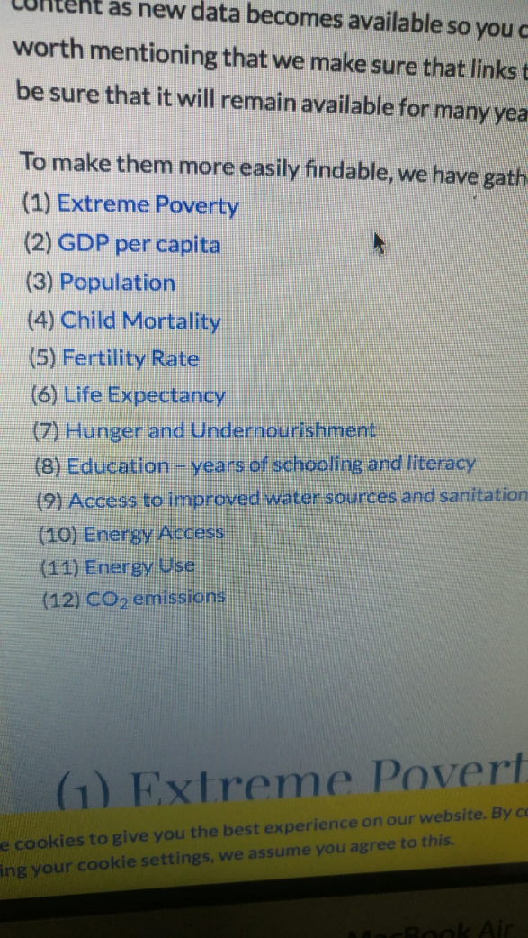

List of countries to work with:

Portugal

Armenia

Brazil

Bangladesh

Datasets to work with: (2005-2016)

1. Total population
2. Population growth
3. GDP per capita
4. ~~GDP growth~~
5. Education (Literacy Rate)
6. ~~CO~~~~2~~ ~~Emission~~
7. alcohol and drug dependency across
8. ~~Trade – exports plus imports – as share of GDP~~

First of all we can make a simple bar chart or box plot or interactive pie chart to present our country’s Data:

Total population  
GDP per capita  
Literacy rate  
Trade

Then we can make some visual presentation of GDP growth, Population growth and CO2 Emission growth

Comparison of two Variables

For each individual country:

* Population Growth vs Literacy Rate
* Trade vs CO2 Emission
* Population Growth vs Alcohol & drugs
* Trade Vs GDP per capita